**UGANDA TECHNOLOGY AND MANAGEMENT UNIVERSITY**

**A PROJECT REPORT ON FOSTER HOME MANAGEMENT SYSTEM**

**BY**

**ISAAC ONGWARA SEP18/BIST/005U**

**MULONGO ERICK SEP18/BCS/OO6U**

**25th November**

Table of Contents

Chapter 1 3

1.1 INTRODUCTION 3

1.1.1 Definition 3

1.1.2 The project consists of two Entities namely; 3

1.1.3 The services of a Foster Home management system include: 3

Chapter 2 4

2.1 Literature Survey 4

2.1.1 4

2.2 Triggers 5

2.3 Stored procedure 5

Chapter 3 6

3.1 ANALYSIS & REQUIREMENT SPECIFICATION 6

3.1.1 Purpose 6

3.1.2 Scope 6

3.1.3 Functional Requirements 6

3.1.4 Non Functional Requirements 6

Chapter 4 7

4.1 DESIGN OF THE PROJECT 7

4.1.1 ER Diagrams 7

Chapter 5 8

5.1 IMPLEMENTATION 8

5.1.1 Table Creation 8

5.1.2 SQLite Outputs snapshots 8

Chapter 6 10

6.1 Snapshots 10

Chapter 7 11

7.1 Conclusion 11

References 12

# Chapter 1

## 1.1 INTRODUCTION

### 1.1.1 Definition

A database management system (DBMS) refers to the technology for creating and managing databases. Basically DBMS is a software tool to organize (create, retrieve, update and manage) data in a database. The main aim of a DBMS is to supply a way to store up and retrieve database information that is both convenient and efficient. By data, we mean known facts that can be recorded and that have embedded meaning.

Database systems are meant to handle large collection of information. Management of data involves both defining structures for storage of information and providing mechanisms that can do the manipulation of those stored information.

Moreover, the database system must ensure the safety of the information stored, despite system crashes or attempts at unauthorized access.

This project is aim at computerizing the manual process of Student’s information.

Front end and backend are implemented using Python Tkinter and Maria Db respectively.

### 1.1.2 The project consists of two Entities namely;

* Parents
* Children

### 1.1.3 The services of a Foster Home management system include:

* Parent Registration
* Parent Details
* Child Registration
* Child Details

# Chapter 2

## Literature Survey

2.1.1 Introduction to Database Management System:

DBMS stands for Database Management System. Database is a collection of data and Management System is a set of programs to store and retrieve those data. DBMS is a collection of inter-related data and set of programs to store and access those data in an easy and effective manner.

Database system is basically developed for large amount of data. When dealing with huge amount of data, there are two things that require optimization: Storage of data and retrieval of data.

According to the principles of database systems, the data is stored in such a way that it acquires a lot less space as the redundant data (duplicate data) has been removed before storage.

Along with storing the data in an optimized and systematic manner, it is also important that we retrieve the data quickly when needed.

Database system ensures that data is retrieved as quickly as possible.

2.1.2 Applications of DBMS

The development of computer graphics has been driven both by the needs of the user community and by the advances in hardware and software. The applications of database are many and varied; it can be divided into four major areas:

1. Hierarchical and network system
2. Flexibility with relational database
3. Object oriented application.
4. Interchanging the data on the web for e-commerce.

2.1.3 Display information

In this particular project, we Python Tkinter as a front end in order to display the information which are stored in the backend database called MariaDb.

**Design Professions** such as engineering and architecture are concerned with design. Starting with a set of specification engineers and architects seek a cost effective and esthetic solutions that satisfies the specifications. Design is an iterative process rarely in the real world is a problem specified such that there is a unique optimal solution. Thus the designer works iteratively.

**User Interfaces** Our interactions with computers has become dominated by a visual paradigm that includes interactive buttons. Although we are familiar with the syntax of MariaDb, advances in MariaDb have made possible other forms of advantages.

# 2.2 Triggers

A database trigger is procedural code that is automatically executed in response to certain events on a particular table or view in a database. The trigger is mostly used for maintaining the integrity of the information on the database. For example, when a new record (representing a new Parent) is added to the Parent table, new records should also be created in the tables of the Child details. Triggers can also be used to log historical data.

2.3 Stored procedure

A stored procedure (also termed proc, storp, sproc, StoPro, StoredProc, StoreProc, sp, or SP) is a subroutine available to applications that access a relational database management system (RDBMS). Such procedures are stored in the database data dictionary.

Uses for stored procedures include data-validation (integrated into the database) or access-control mechanisms. Furthermore, stored procedures can consolidate and centralize logic that was originally implemented in applications. To save time and memory, extensive or complex processing that requires execution of several SQL statements can be saved into stored procedures, and all applications call the procedures. One can use nested stored procedures by executing one stored procedure from within another.

# Chapter 3

## 3.1 ANALYSIS & REQUIREMENT SPECIFICATION

3.1.1 Purpose

The purpose of this project is to outline parent and Child records, to recommend data management solutions and to provide information regarding the Child. The purpose of this project is to develop a data management system to consolidate, organize, document, store and distribute information related to Foster Home management system.

A centralized database created to consolidate data, allowing integrated, long term analyses, and dynamic search ability with user friendly query tools to be performed to support adaptive management. Many data collection, analysis and presentation software programs that are currently being used must be able to interface with any new data management system. Continuity with consistent data collection methodology is enforced by a common database system, allowing for standardized format for forms ad reports between projects.

3.1.2 Scope

The scope of the project is managing a consistency and storage of data by dedicated data administrator. It provides most of the features that a Database Management System should have. It is developed by using Maria database. It has been implemented in WINDOWS and LINUX platform.

3.1.3 Functional Requirements

Three modules are used in this project namely Admin, Student, Enquiry

* **Children:** can be linked to child detail.
* **Parents:** can be linked to parent details.

3.1.4 Non Functional Requirements

* **Hardware specification**
* Processor: dual core and I series i.e. i3,i5,i7 series
* Clock speed: 2.5GHz
* Monitor : 1024 * 768 Resolution Color
* Keyboard: QWERTY
* **Software specification**
* Spyder or Idle IDE

# Chapter 4

## 4.1 DESIGN OF THE PROJECT

This project has been developed using Maria Db software which is queries oriented. Changes at the queries and the way in which it uses a system state may cause anticipated changes in the behavior of other result.

### 4.1.1 ER Diagrams

Parent

Children

Child Number

Given Name

Middle Name

Surname

Father’s Name

Mother’s Name

Date of Birth

Place of Birth

Date of Arrival

Gender

Address

Has

Foster’s Name

Foster Number

Foster Father

Foster Mother

Email

Address

Contact

Date of Foster

# Chapter 5

## 5.1 IMPLEMENTATION

The project is implemented using Maria database along with Python and Tkinter.

### 5.1.1 Table Creation

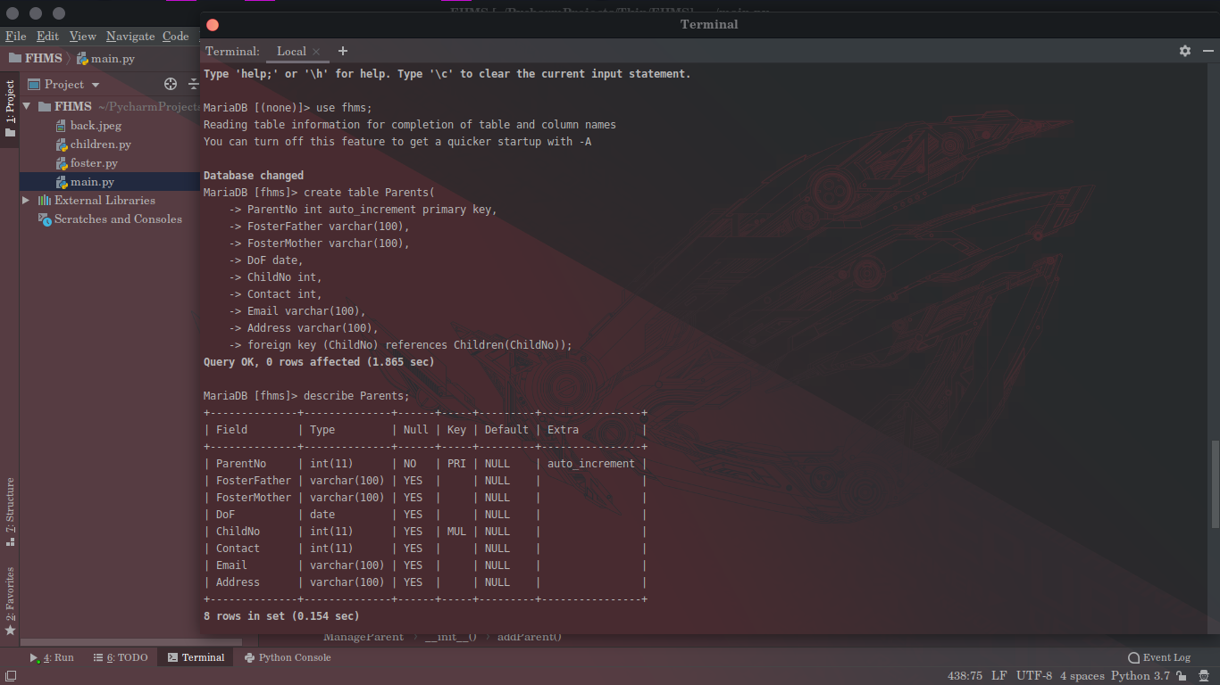

### 5.1.2 Mysql Outputs snapshots

**a) Db Connection**

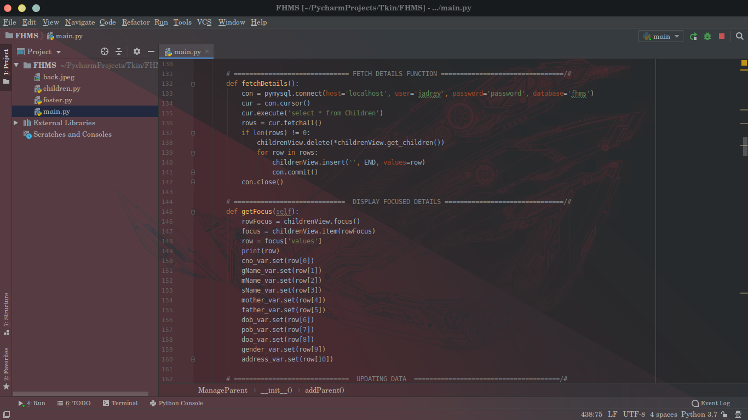

**b) Table creation**



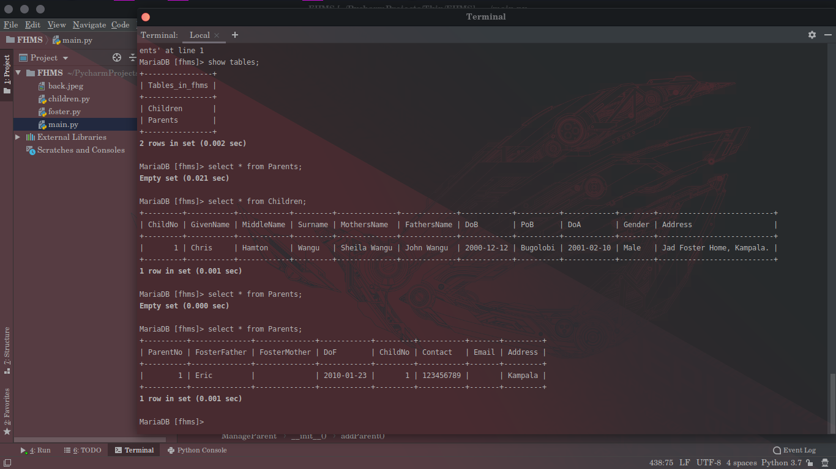

# Chapter 6

## 6.1 Snapshots

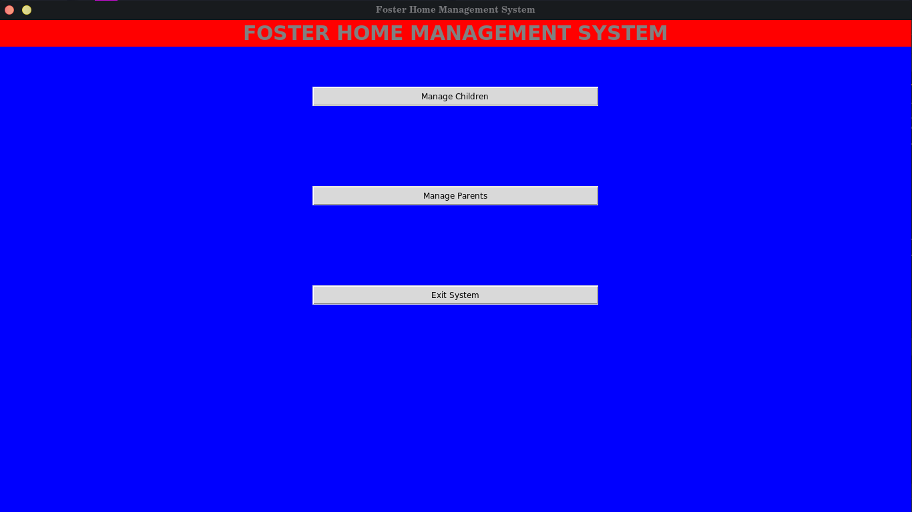

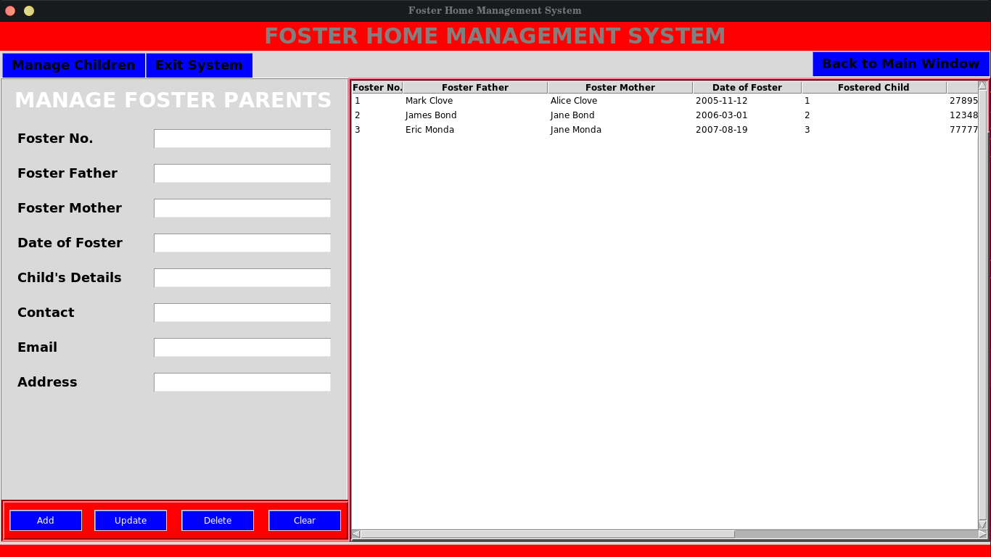

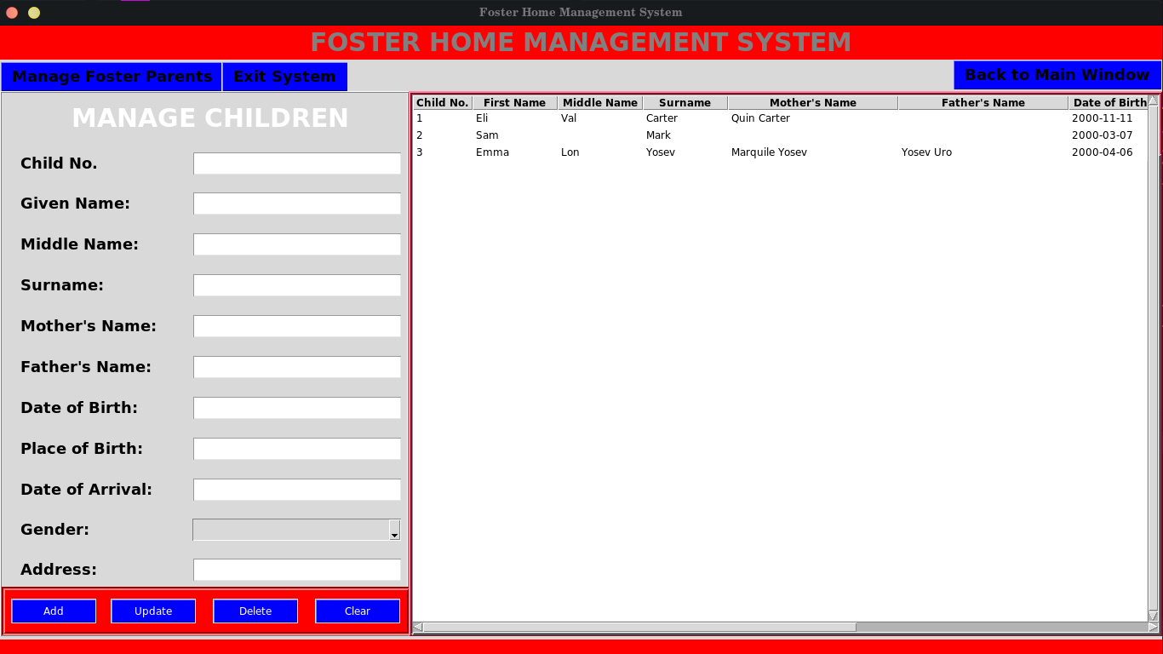

# Chapter 7

## 7.1 Conclusion

In this project we have created one application which is easy to access and user friendly. The application keeps a backup of the parents and children data which includes their details.

# References

1. http://wikipedia.com/wiki/MariaDb
2. Database Systems Models,Languages,Design and Application Programming, RamezElmasri and Shamkant B. Navathe, 7th Edition, 2017, Pearson.